Directions:
1. Create PERSIAN chart (at least 4 points for each letter) for historical/social context of image
2. Write 1 page defense statement using all 3 rhetorical appeals.
3. Present your statement to class (not word for word & must include a visual)
- Ending DACA (Deferred Action for Childhood Arrivals) Article
Defense: Ending this program is not fair to children who were brought to and raised in America.
- Black lives matter Article c
Defense:
The black lives matter movement is meant to support the fair treatment of minorities in the United States.
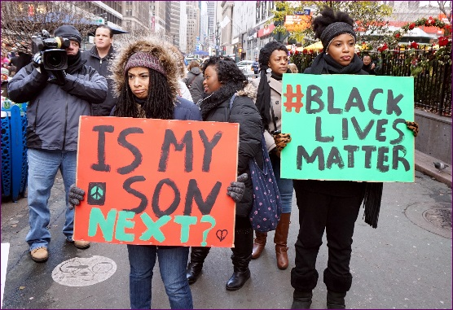
Gun Control Article
Defense: Gun control laws are needed to keep people safe
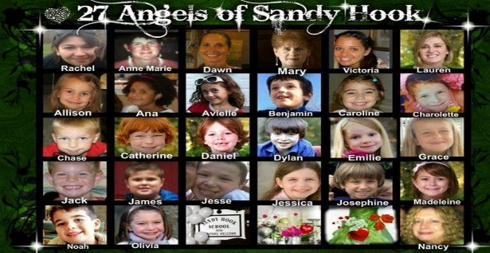

- Natural Disaster Survivors
Defense: FEMA needs to provide more support to survivors of natural disasters Article

5. The importance of Culture and tradition Article
Defense: India’s women are being destroyed their own culture
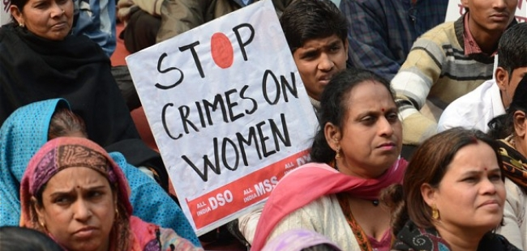

- Nationalism article
Defense: Nationalism should not mean supporting the erradication of other ethnic groups
