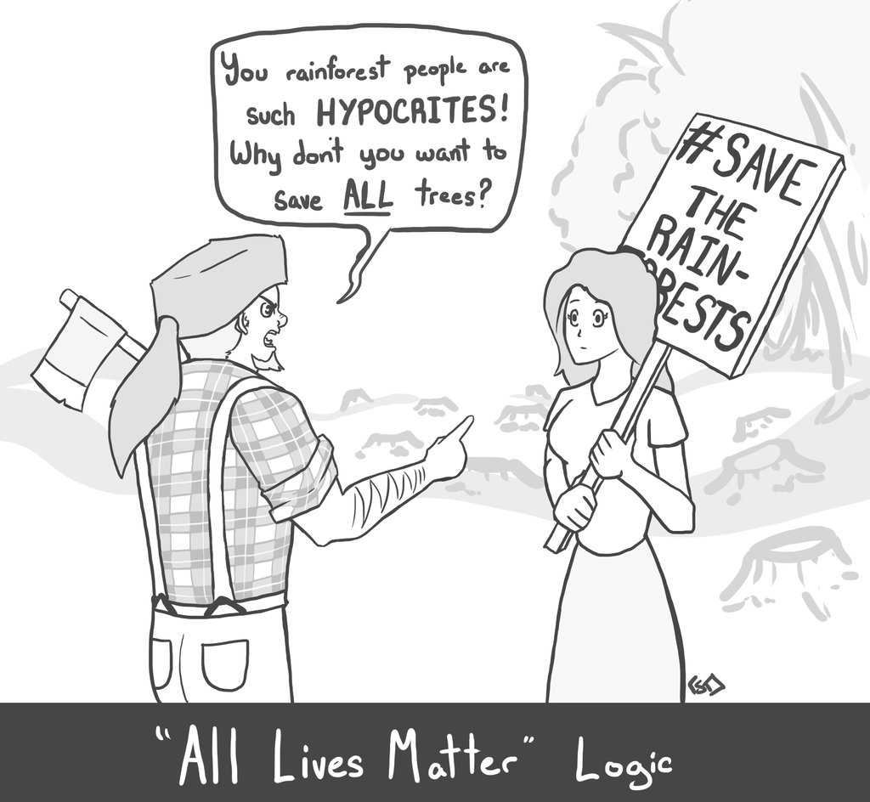

|  |  |  |
| --- | --- | --- |
| **OBSERVE** | **REFLECT** | **QUESTIONS** |
| * What do you notice first? * What people and objects are shown? * What, if any, words do you see? * What do you see that looks   different than it would in a  Photograph?     * What do you see that might refer to another work of art or literature? * What do you see that might be a symbol? | * What’s happening in this cartoon? * When do you think this cartoon was made? * Who do you think was the audience for this cartoon? * What issue do you think this cartoon is about? * What do you think the cartoonist’s opinion on this issue is? * What methods does the cartoonist use to persuade the audience? | * What does it all mean? * What is the purpose of this political cartoon?     ***You must ask at least 2 more questions that you may have regarding the actual cartoon and/or issues regarding |